Powerful Learning with Raine in the Underlands
 | Romi Sharp  Nov 21
Raine in the Underlands: The Lorekeepers by E M Greville is a story of a young, seemingly ordinary pre-teen suddenly thrust into a supernatural world, which begins her journey of unravelling her own identity and powers she could never have imagined. This chapter book is the first in this exciting series for middle grade lovers of fantasy, suspense, magic, humour and action all combined in one EPIC adventure. Through reading, discussion and further analysis, there's plenty of wondrous and fascinating lessons to explore. Let's take a look at a few ideas for students in middle and upper primary grades.
Discussion:
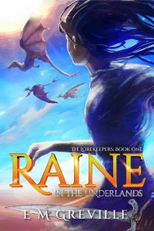
Look at the cover of Raine in the Underlands: The Lorekeepers. What do you notice? What does it make you wonder? How do you think the character is feeling? How does it make YOU feel? What do you think this story is about?
Read the blurb. Discuss.
If you suddenly discovered that you had magical powers, what would you do with them? Why?
What are the main themes of the story? What important messages does the author intend to portray? What is your favourite part/s of the story? Why?
What did you learn about Raine? How did her self-confidence and feelings change throughout the story? What did you learn about some of the other characters?
What kinds of challenges might Raine face in future adventures?
Discuss different kinds of tales (fairy tales, folktales, mythical legends, etc). What are the similarities and differences between them? How does Raine in the Underlands incorporate elements of these tales? Create a Venn Diagram to represent your thoughts and information.
Activities:
Themes:
Family relationships, Humour, Friendship, Good vs Evil, Self-Identity, Fantasy
English: Years 3 to 6
Character Analysis
Years 3 & 4 English: (ACELA1493) (ACELA1498) (ACELT1594) (ACELT1604) (ACELT1605) (ACELT1791) (ACELT1794) (ACELY1680) (ACELY1692) Years 5 & 6 English: (ACELA1508) (ACELA1524) (ACELA1525) (ACELT1611)(ACELT1612) (ACELT1800) (ACELY1703) (ACELY1713) (ACELY1704) (ACELY1714)
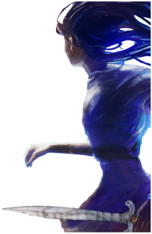
Use the following acronym (STEAL) to identify features of Raine or another chosen character from Raine in the Underlands. Find parts of the text to show the way they Speak, Think, Effect on others, Act and Look.
Speech – what does the character say? How do they speak?
Thought – what are the character’s thoughts and feelings?
Effect on others – how do people react to the character?
Actions – what does the character do?
Looks – what does the character look like?
1. Choose a character to create a character profile page, including a name, picture, adjectives / descriptive language to describe their appearance, personality traits, interests, dislikes, and so on.
2. Use the STEAL method to develop your own character when writing a narrative.
Drama: Years 3 to 6
Stick Puppet or Theatre Role Play
Years 3 & 4 Drama: (ACADRM031) (ACADRM032) (ACADRM033) Years 5 & 6 Drama: (ACADRM035) (ACADRM036) (ACADRM037)
Years 3 & 4 Visual Arts: (ACAVAM111) (ACAVAM112) Years 5 & 6 Visual Arts: (ACAVAM115) (ACAVAM116)
There are some wonderfully unique and fascinating characters in Raine in the Underlands, including Raine, Little Thirty-Five, Monkey, Uncle Johnny, Elsie (Mum), plus more! The characters certainly present in many different curious, humorous and EPIC situations! Decide on a scene with your favourite characters. Draw your chosen characters onto paper, cut out and attach with a pop stick. Now watch your drawings magically come to life! Role play your favourite scenes and share as a presentation. Students might like to work in groups. Alternatively, make props and costumes to perform a theatre show.
STEAM / Science: Years 3 to 6
Burping / Farting Dragon Experiment
Science: Years 3 & 4 Science: (ACSSU046) (ACSSU074) (ACSHE050) (ACSHE061) (ACSHE062) (ACSIS053) (ACSIS065) (ACSIS066) (ACSIS215 ) (ACSIS069) (ACSIS071) Years 5 & 6 Science: (ACSSU077) (ACSSU095) (ACSHE081) (ACSHE098) (ACSIS231) (ACSIS086) (ACSIS104) (ACSIS090) (ACSIS221) (ACSIS091) (ACSIS093) (ACSIS110)
Visual Arts: Years 3 & 4 Art: (ACAVAM110) (ACAVAM111) (ACAVAM112) (ACAVAR113) Years 5 & 6 Art: (ACAVAM114) (ACAVAM115) (ACAVAM116) (ACAVAR117)
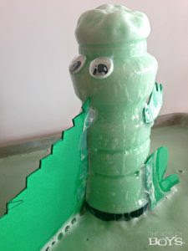
Make your own magical burping (or farting) Little Thirty-Five dragon with this fun, explosive experiment! The full instructions can be found at Foaming Dragon Science Experiment (thejoysofboys.com)
Students can predict, observe, evaluate and record the results. They can also compare variations using two methods.
Materials needed include: plastic wide-mouth bottle, green cardstock or craft foam, paper pen, tape, vinegar, baking soda, dishwashing liquid, food colouring.
Chemical reaction: When you mix vinegar and baking soda it makes carbon dioxide. This forms bubbles in the vinegar and causes it to expand.
More dragon STEM activities can be found at Dragon STEM Activities for Kids (theresjustonemommy.com).
Raine in the Underlands: The Lorekeepers is written by E M Greville and published by Shawline Publishing. Notes prepared by Romi Sharp.

